ST. JOSEPH’S CATHEDRAL HIGH SCHOOL
COMPUTER SCIENCE 2
CANDIDATE NAME: PROSPER LUKAMAJA MASUNGA

QUESTION 1:
- Source code for the given program:
#include <iostream>
#include <string>
#include <iomanip>
#include <vector>
using namespace std;

const float TAX_RATE = 0.1;

class Employee {
private:
string name;
int employeeID;
float basicSalary;
float allowance;

public:
Employee(string employeeName, int id, float salary, float employeeAllowance) :
name(employeeName), employeeID(id), basicSalary(salary), allowance(employeeAllowance) {}

const float calculateNetSalary() {
return (1 - TAX_RATE) * (getBasicSalary() + getAllowance());
}

void displayDetails() {
cout << "Employee ID: " << setw(50) << getEmployeeID() << endl
<< "Employee Name: " << setw(50) << getName() << endl
<< "Basic salary: " << setw(50) << setprecision(10) << getBasicSalary() << endl
<< "Allowance: " << setw(50) << setprecision(10) << getAllowance() << endl
<< "Net salary: " << setw(50) << setprecision(10) << calculateNetSalary() << endl;
}

// Create appropriate setter and getter functions to enforce encapsulation
int getEmployeeID() { return employeeID; }

string getName() { return name; }

float getBasicSalary() { return basicSalary; }

float getAllowance() { return allowance; }
};

class Manager: public Employee {
private:
float bonus;

public:
Manager(string managerName, int id, float managerSalary, float managerAllowance, float bonusAmount) :
Employee(managerName, id, managerSalary, managerAllowance), bonus(bonusAmount) {}

const float calculateNetSalary() {
return (1 - TAX_RATE) * (getBasicSalary() + getAllowance() + getBonus());
}

float getBonus() { return bonus; }

void displayDetails()
{
cout << "Employee ID: " << setw(50) << getEmployeeID() << endl
<< "Employee Name: " << setw(50) << getName() << endl
<< "Basic salary: " << setw(50) << setprecision(10) << getBasicSalary() << endl
<< "Allowance: " << setw(50) << setprecision(10) << getAllowance() << endl
<< "Net salary: " << setw(50) << setprecision(10) << calculateNetSalary() << endl
<< "Bonus: " << setw(50) << setprecision(10) << getBonus() << endl;
}
};

int main()
{
// Create 3 objects of the Employee class using an array
vector<Employee> employees;
cout << showpoint;

// Accept input from the user for each employee
cout << "------------------ Welcome to BRIGHT WORKS LTD!!! ------------------" << endl;
cout << "\nYou are required to input data for three(3) employees.........." << endl;
string name;
int employeeID;
float basicSalary, allowance;

for (int i = 0; i < 3; ++i) {
cout << "\nEMPLOYEE #" << i + 1 << endl;
cout << "Name of the employee: ";
cin >> name;
cout << "Employee ID: ";
cin >> employeeID;
cout << "Basic salary for '" << name << "'(TZS): ";
cin >> basicSalary;
cout << "Allowance for '" << name << "'(TZS): ";
cin >> allowance;

employees.push_back(Employee(name, employeeID, basicSalary, allowance));
}

// Output data for each employee
cout << "\n\nOUTPUT DATA FOR EACH EMPLOYEE....." << endl;
for (int i = 0; i < 3; ++i)
{
employees[i].displayDetails();
cout << endl;
}

// Create one Manager object
Manager manager("Festo Brendan", 1, 10000000.00, 2000000.00, 500000.00);
cout << "\n\nDISPLAYING THE MANAGER'S DETAILS......" << endl;
manager.displayDetails();
}

- Screenshot of output obtained
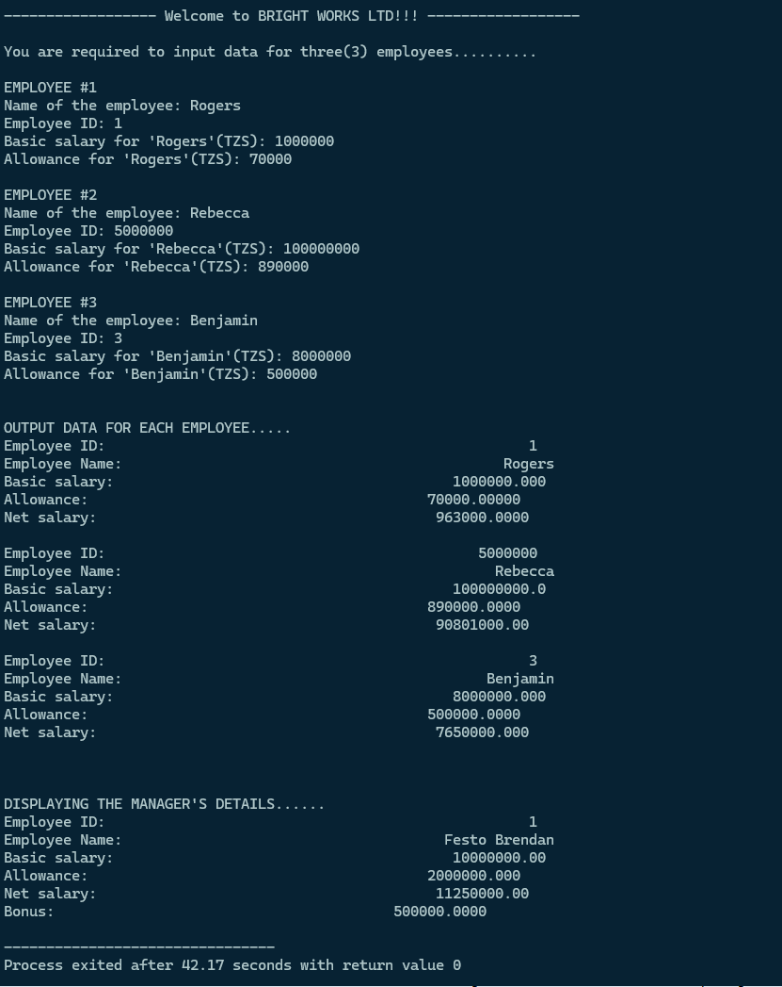

QUESTION 2:
(A) Source code (SQL)
-- (a) Create the database 'school_db' and a table named 'students'
CREATE DATABASE school_db;
USE school_db;

CREATE TABLE students (
student_id INT PRIMARY KEY,
full_name VARCHAR(100),
gender VARCHAR(10),
age INT,
combination VARCHAR(20)
);

-- (b) Enter data into the students table
INSERT INTO students VALUES
(1001, 'John Peter', 'Male', 18, 'PCM'),
(1002, 'Asha Juma', 'Female', 17, 'PCB'),
(1003, 'David Michael', 'Male', 19, 'CBG'),
(1004, 'Neema Joseph', 'Female', 18, 'PCM'),
(1005, 'Robert James', 'Male', 17, 'PCB'),
(1006, 'Mary Thomas', 'Female', 19, 'CBA'),
(1007, 'Kelvin George', 'Male', 18, 'PCM'),
(1008, 'Rehema Said', 'Female', 17, 'PCB');

-- i. Change John Peter's age to 19
UPDATE students SET age = 19 WHERE student_id = 1001;

-- ii. Change Kelvin George's Combination to PCB
UPDATE students SET combination = 'PCB' WHERE student_id = 1007;

-- iii. Delete the record of Robert James
DELETE FROM students WHERE full_name = 'Robert James';

-- iv. Display all students
SELECT * FROM students;

-- v. Display all students taking PCM
SELECT * FROM students WHERE combination = 'PCM';

-- vi. Display all students aged 18
SELECT * FROM students WHERE age = 18;

-- (c) Add field 'phone_number' to students table
ALTER TABLE students ADD phone_number VARCHAR(10) NOT NULL AFTER combination;

-- Enter the given phone numbers
UPDATE students SET phone_number = '0712345678' WHERE student_id = 1001;
UPDATE students SET phone_number = '0756789123' WHERE student_id = 1002;
UPDATE students SET phone_number = '0765432109' WHERE student_id = 1003;
UPDATE students SET phone_number = '0789123456' WHERE student_id = 1004;

- Screenshots
(i)Output of the select all rows query after completing the entire database
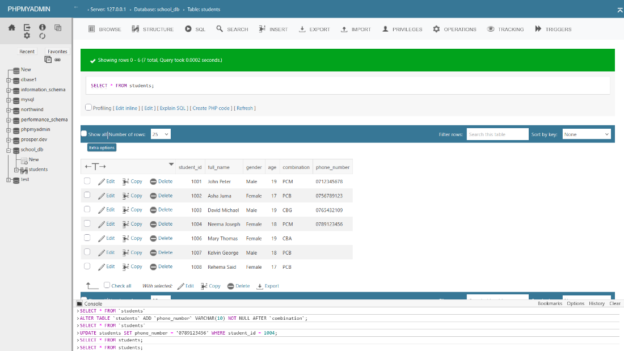

(ii) Selected students with age 18
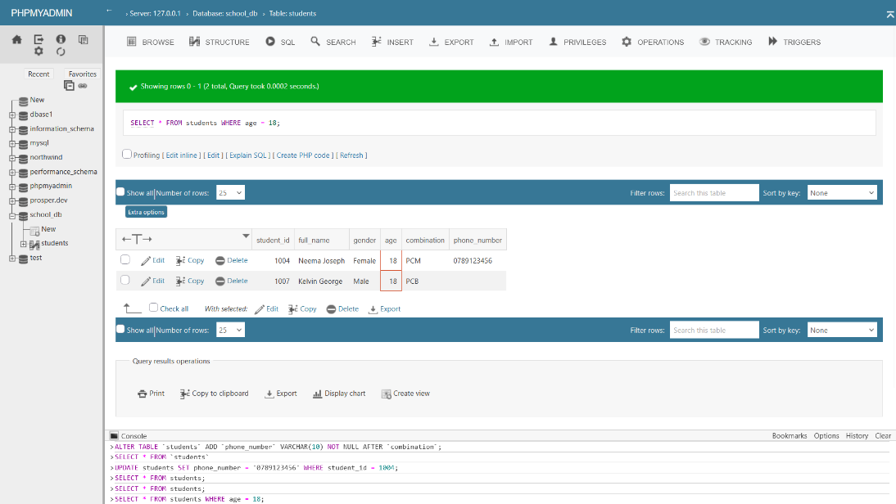

(iii) Selected students taking PCM combination



